**Lab 1: Soil Classification**

HAVE YOU NOTICED at construction sites how a cross section of soil has a layered look? Soil near the top of the cross section is often dark, and soil below appears lighter. What you have seen is a soil profile. In this lab, factors that contribute to the layered look you have seen will be discussed.

**Factors affecting soil formation**

Soil forms continuously, but slowly, from the gradual breakdown of rocks through weathering. Weathering can be a physical, chemical or biological process:

* physical weathering—breakdown of rocks from the result of a mechanical action. Temperature changes, abrasion (when rocks collide with each other) or frost can all cause rocks to break down.
* chemical weathering—breakdown of rocks through a change in their chemical makeup. This can happen when the minerals within rocks react with water, air or other chemicals.
* biological weathering—the breakdown of rocks by living things. Burrowing animals help water and air get into rock, and plant roots can grow into cracks in the rock, making it split.

The accumulation of material through the action of water, wind and gravity also contributes to soil formation. These processes can be very slow, taking many tens of thousands of years. Five main interacting factors affect the formation of soil:

* 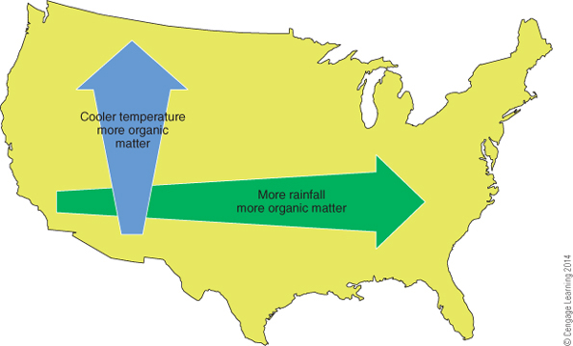**Parent Material**:the original “Mom & Pop” soil transported from elsewhere, usually by wind or water, at different speeds
* **Climate:** the amount, intensity, timing, and kind of precipitation that breaks down parts of ecosystem (i.e. rocks, trees) into soil
* **Topography:** *Slope* and *Aspect* affect the angle of the land and position toward/away from the sun that soil will be exposed to
* **Biological:** Plants, animals, microscopic organisms, and humans interact with soil in different ways
* **Time:** the amount of time it takes for the four factors (above) to interact with each other

Interactions between these factors produce an infinite variety of soils across the earth’s surface.

**Parent Materials**

Soil minerals form the basis of soil. They are produced from rocks (parent material) through the processes of weathering and natural erosion. Water, wind, temperature change, gravity, chemical interaction, living organisms and pressure differences all help break down parent material.

The types of parent materials and the conditions under which they break down will influence the properties of the soil formed. For example, soils formed from granite are often sandy and infertile whereas basalt under moist conditions breaks down to form fertile, clay soils.

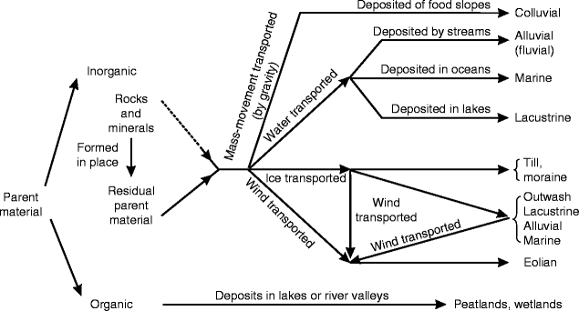

**Soil Profile**

A **soil profile** is a vertical cross section of the soil. When exposed, various **soil horizons**, or layers of soil, become apparent. Each horizon of soil may be different from the other horizons in physical or chemical ways. The differences are developed from the interaction of such soil-forming factors as parent material, slope, native vegetation, weathering, and climate.

A soil profile is usually studied to a depth of 3 to 5 feet. To see the soil profile, soil cores may be taken or holes dug to expose the profile. A soil core or auger allows the extraction of a cylinder of soil for study.

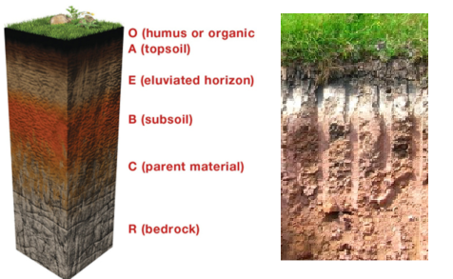**Soil Horizons**

There are three primary soil horizons, called master horizons. They are A, B, and C. These are part of a system for naming soil horizons in which each layer is identified by a code: O, A, E, B, C, and R.

* The **O horizon** is an **organic layer** made up of partially decayed plant and animal debris. It generally occurs in undisturbed soil, such as in a forest.
* The **A horizon** is often referred to as the **topsoil** and is the surface layer where organic matter accumulates. Over time, this layer loses clay, iron, and other materials because of leaching. The movement of organic matter, chemical substances, and mineral particles from the upper horizons of soil to the lower horizons by the downward movement of water is called eluviation. The A horizon provides the best environment for the growth of plant roots, microorganisms, and other life.
* The **E horizon** is the zone of greatest **eluviation**. Because the clay, chemicals, and organic matter are leached, the color of the E horizon is very light. This horizon usually occurs in sandy forest soils with high amounts of rainfall.
* The **B horizon** is often referred to as the **subsoil**. It is often called the “zone of accumulation” because chemicals leached from the A and E horizons accumulate here. The accumulation of organic matter, chemical substances, and mineral particles in the lower horizons of soil from the upper horizons as a result of the downward movement of water is called **illuviation**. The B horizon has less organic matter and more clay than the A horizon. Together, the A, E, and B horizons are known as the solum. This is where most of the plant roots grow.
* The **C horizon** is called the substratum. It lacks the properties of the A and B horizons because it is influenced less by the soil-forming processes. It is usually the **parent material** of the soil.
* The **R horizon** is the underlying **bedrock**, such as limestone, sandstone, or granite. It is found beneath the C horizon.

**Soil Orders**

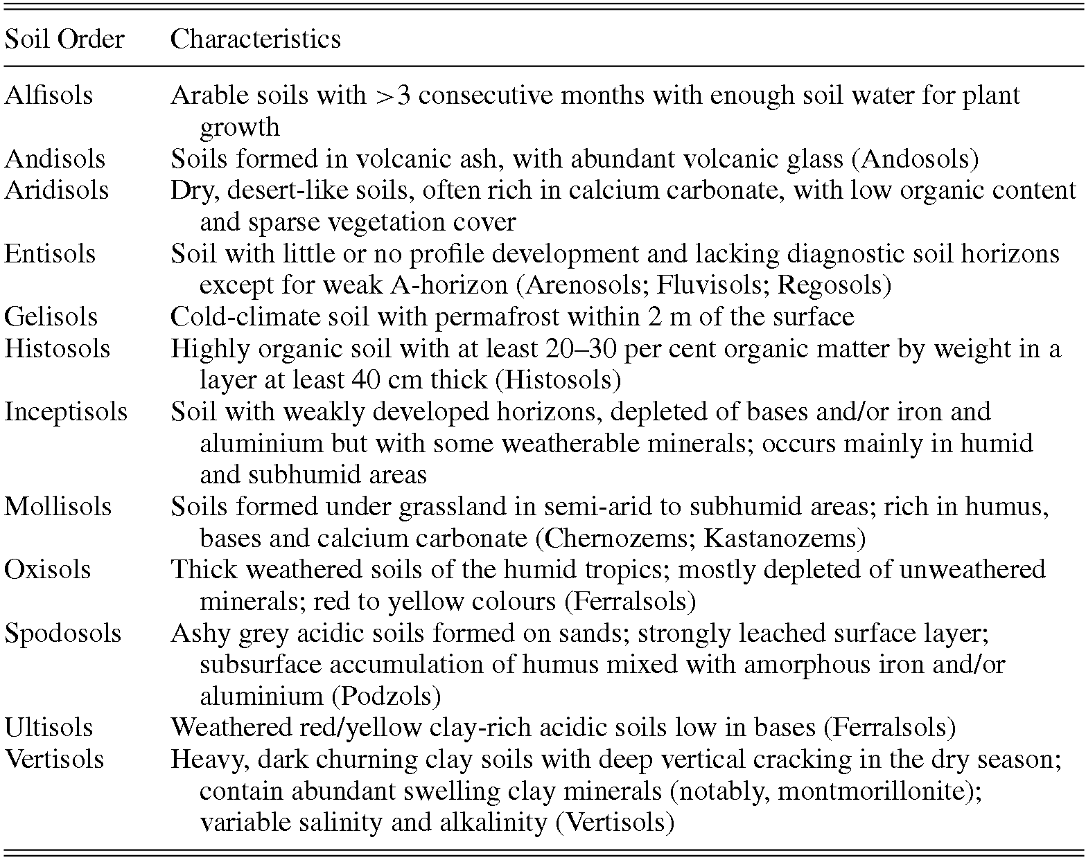

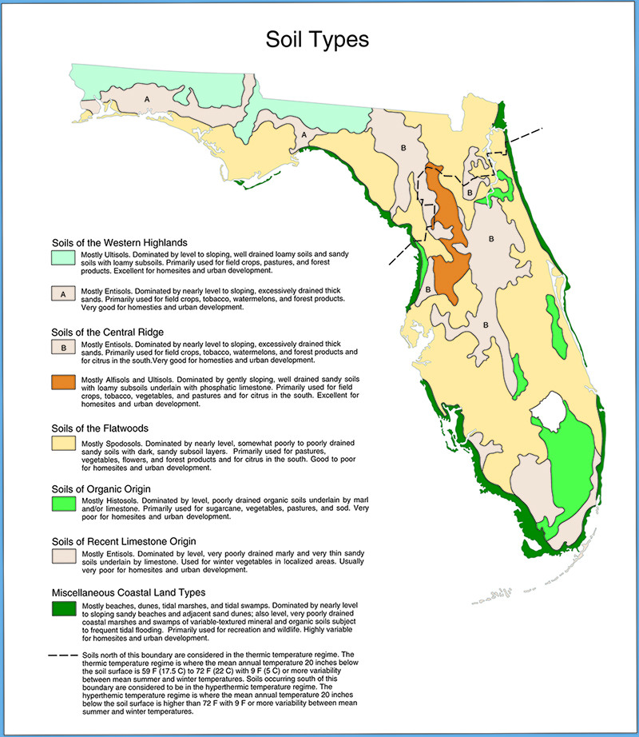

**Soil Profile Activity**

**Directions:** Using the soil profile from one of the locations, answer the questions. The soil profiles were created using [SoilWeb](https://casoilresource.lawr.ucdavis.edu/gmap/).

**Your Soil Profile**

1. What soil profile do you have (location, series)? **Lake County, FL - Candler**
2. Using the information above, describe your soil order.

**Candler is an Entisol, meaning it does not fit into the other orders.**

1. Describe the soil horizons (color, types, % organic matter, length, etc.).

**Candler has an A horizon, then two E horizons and a E+B horizon at the bottom. The A topsoil horizon has ~2.1% organic matter and is 0-5 inches deep. The middle E horizons have roughly 0.3% organic matter and stretch from the bottom of the topsoil to 160 feet underground. The E+B subsoil horizon has a very low organic matter content of less than 0.1%, and goes beyond 200 feet. The Ksat measure for water permeability for the three top horizons is 510 mm/hr, with the subsoil permeability dropping to around 330 mm/hr.**

1. Based on the description of the soil, how would describe its parent material.

**All of the layers are mostly sand, with the topsoil having the lowest % sand at 96.7%. Based on this high sand content, it seems likely the soil formed from silica-containing rocks. Being in Florida, it’s probably safe to assume they were of marine origin.**

**Similar Soil Order**

1. Locate the same soil order in another location. Location and series: **Clermont, Florida - Candler**
2. Describe the similarities and differences between the two.

**Both soils are deep with high drainage. Both soils also have a topsoil level with 1-2% organic matter, then very little organic matter on the lower horizons. Both soils have one topsoil horizon with two E horizons. One difference is the first soil has one subsoil horizon, while the Clermont entisol has 3 subsoil horizons.**

**Florida Soils**

Take a look at the Florida soils. Review information on each card.

1. What is the predominant soil texture (i.e. mainly sand, silt, or clay)? **Sand**
2. Identify two parent materials. **Silica is definitely a parent material due to the high sand content. Quartz is a definite possibility due to its high silica content.**
3. Choose two locations. What crops are they likely to produce based on the soil order and location? You can refer to the figure of Florida with associated orders and crops.

Location: **Jefferson County, FL - Ultisol** Crops: **Field crops, pastures, forest products**

Location: **Lake City, FL - Alfisol** Crops: **Field crops, tobacco, watermelons, citrus, watermelons**

**Soils of the United States**

Review the various soil profiles and answer the following questions.

1. How does % of organic matter change depending on the location (climate) in the US?

**Similar farmland near the Michigan coast of Lake Michigan, while also classified as an Entisol, contains over 4% organic matter. This is likely because of the generally colder temperatures slowing the decay of organic matter.**

1. How does the soil texture change depending on the location in the US?

**Areas near the coast of the oceans or great lakes have higher sand content due to the greater erosion forces taking place. Areas further inland tend to have higher clay content.**

1. Compare the horizons of two soil orders, different than what you already looked, to its description on page 3.

**The first soil is in Fort Fairfield, Maine and is a Spodosol. This spodosol has a 20cm thick topsoil layer with over 5% organic matter, which matches the humus accumulation in the description.**

**The second soil is a Entisol from San Bernardino, CA. This entisol has weak separation between the horizons, with three C horizons. This is consistent with the description, except this soil has no A horizon at all.**

**Discussion Questions:**

1. What is a soil profile?

**A soil profile is a by-the-numbers summary of a soil’s physical properties and composition.**

1. What factors are involved in the development of soil profiles?

**The concentration of clay, silt, and sand particles is essential. Additionally, pH, electrical conductivity, water permeability, and organic matter content are also considered.**

1. What are the master horizons?

**O – organic matter**

**A - topsoil**

**E - eluviation**

**B - subsoil**

**C – substratum, typically consists of the parent material  
R - bedrock**

1. How do eluviation and illuviation differ?

**Eluviation involves the transport of materials through the soil, specifically material being removed from a layer. Illuviation involves the deposition of material into a layer.**

1. How can soil profiles differ even if they are in the same soil order?

**Soils in the same order can be made of different parent rocks due to their different locations. A soil in one order in a cold environment may have more organic content than the same soil order in a warmer climate. Hydration is another factor that can differ and will have a direct effect on the EC reading of a soil profile.**

1. Describe how three types of parent material are made (e.g. colluvium, alluvium, till, lacustrine, marine, eolian, organic).

**Alluvium is formed through the minerals and parent materials being deposited by streams. Lacustrine is similar, but rather than the materials being deposited by streams, they are deposited by lakes. Moraine parent materials are formed through ice transportation in a glacial till, where a glacier deposits material as it moves.**

1. How can the soil profile affect what type of crop can be planted and why?

**The soil profile contains information like the pH, hydration, permeability, and organic matter content. Different crops will have different requirements for their soil. For instance, blueberries grow best in acidic soil, while that same soil may be harmful to other crop species.**